create table destination  
(  
 id int auto_increment  
 primary key,  
 name varchar(255) not null,  
 constraint UK_kw349sqcyo1k39xa0wn3k3q2r  
 unique (name)  
);  
  
create table user  
(  
 id int auto_increment  
 primary key,  
 password varchar(255) not null,  
 role varchar(255) not null,  
 username varchar(255) not null,  
 constraint UK_sb8bbouer5wak8vyiiy4pf2bx  
 unique (username)  
);  
  
create table vacation  
(  
 id int auto_increment  
 primary key,  
 limitB varchar(255) not null,  
 name varchar(255) not null,  
 status varchar(255) not null,  
 vacation_id int null,  
 constraint UK_48h5l08lb8idl66k48694f9w  
 unique (name),  
 constraint FKcisqp45yhkqaaquvjd8q34pqn  
 foreign key (vacation_id) references destination (id)  
);  
  
create table user_vacation  
(  
 user_id int not null,  
 vacation_id int not null,  
 constraint FK3nvw9gc3fkt5i27ll8238rp2f  
 foreign key (user_id) references user (id),  
 constraint FKjh4i8yihj2oqnvqjg089v3kse  
 foreign key (vacation_id) references vacation (id)  
);

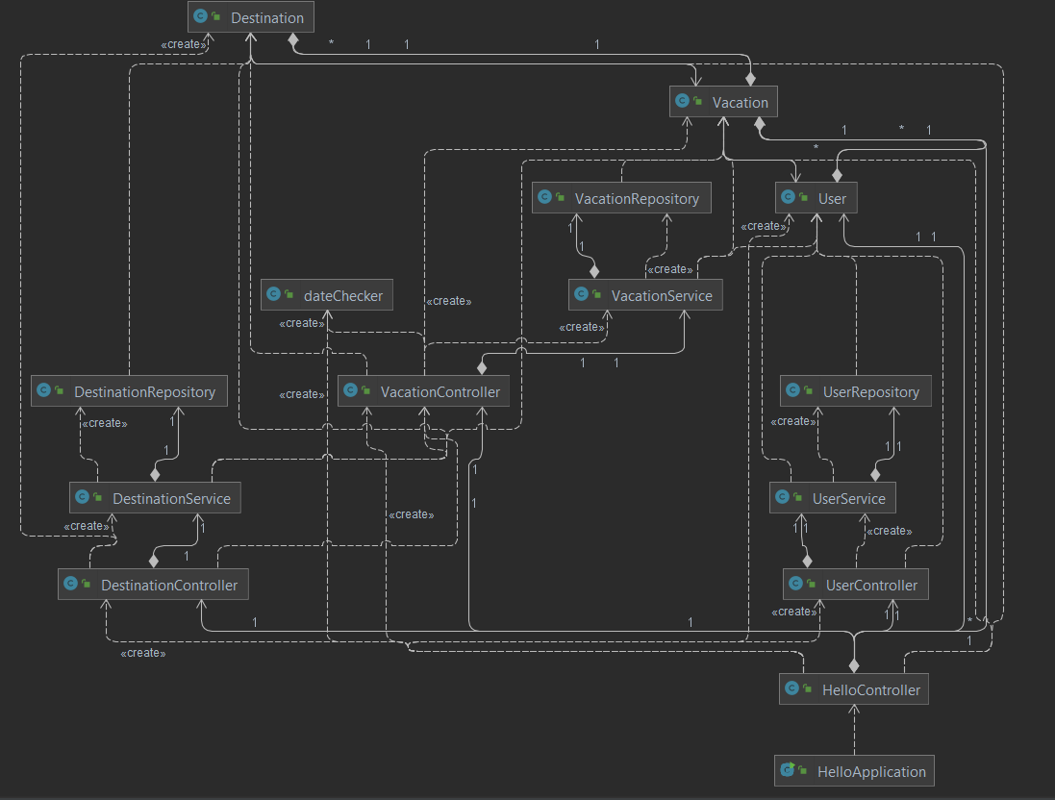

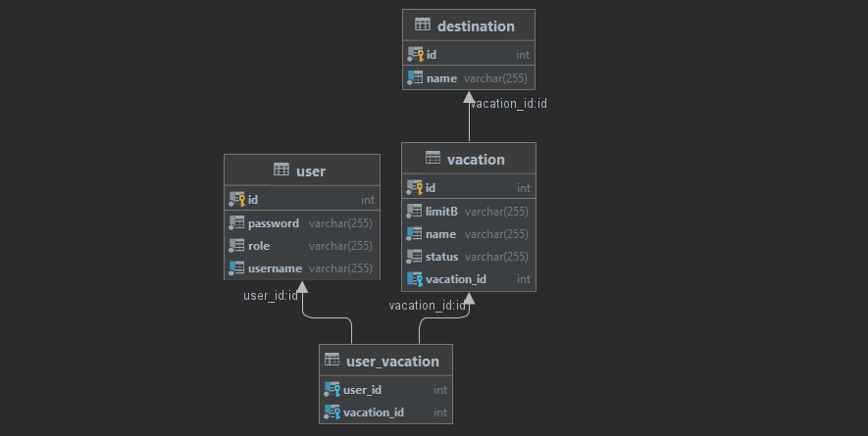

See Packages

Modify Package

Add/Delete Package

Add/Delete Destination

Search Package

Book/Unbook

Log In

Sign Up

Agency

User